Q1. What is the relationship between classes and modules?

Ans: - Classes and modules in Python serve different purposes. A class is a blueprint for creating objects (a particular data structure), providing initial values for state (member variables or attributes), and implementations of behavior (member functions or methods). On the other hand, a module is a file containing Python definitions and statements. The definitions inside a module can be imported to another module or the interactive interpreter in Python.

Q2. How do you make instances and classes?

Ans: - In Python, a class is defined using the class keyword, followed by the **class** name and a colon. Inside the class, methods (functions) are defined using the **def** keyword. An instance of a class (an object) is created by calling the class name as if it were a function. Here is an example:

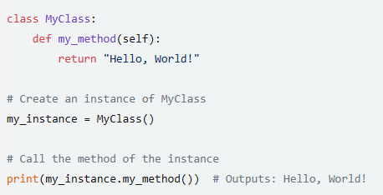

Q3. Where and how should be class attributes created?

Ans: - Class attributes in Python are created within the class definition. They are typically placed at the top of the class and represent data that is shared among all instances of that class. Here is an example:

Q4. Where and how are instance attributes created?

Ans: - Instance attributes in Python are created within methods of a class, typically within the __init__ method. They are prefixed with self, which refers to the instance of the class. Here is an example:

Q5. What does the term "self" in a Python class mean?

Ans: - In Python, self is a reference to the instance of the class. It is the first parameter in any method of a class. By convention, self is used as the first parameter in instance methods to refer to the instance the method is called on.

Q6. How does a Python class handle operator overloading?

Ans: - Python allows operator overloading by defining special methods in the class, also known as dunder methods. For example, to overload the + operator, you would define a method named __add__ in your class.

Q7. When do you consider allowing operator overloading of your classes?

Ans: - Operator overloading can be considered when you want to provide a natural and intuitive interface for your class, or when you want your objects to interact with operators in a specific way. It can improve code readability and make your code more concise and expressive.

Q8. What is the most popular form of operator overloading?

Ans: - The most common form of operator overloading in Python is likely the overloading of the + operator, which is used for addition for numeric types, concatenation for strings, and merging for lists

Q9. What are the two most important concepts to grasp to comprehend Python OOP code?

Ans: - The two most important concepts in understanding Python Object-Oriented Programming (OOP) are probably classes and objects. A class is a blueprint for creating objects, providing initial values for state and implementations of behavior. An object is an instance of a class, and it can have its state and access to all of the behaviors defined in its class.